Inception Report

Contents
- Contents
- Acronyms
• Acronyms
- Acknowledgments
- Executive Summary
  - Introduction
  - Scope
  - Requirements Gathering Participants
    - Day 1
    - Day 2
    - Day 3
- Summary of Key Findings
  - Summary table of requirements.
  - Other Findings and Recommendations
  - Infrastructure
    - Hardware Findings
      - Current Infrastructure
      - Proposed Infrastructure
  - Operations and Roles
    - Partners UNFPA and UNICEF
    - Administrator
    - Counselor
    - Supervisor
    - Case Manager
    - Case Worker
  - Case Escalation Process
  - Case Categories
  - Reporting Module
    - Pivot Reports
    - Comprehensive Reports
  - Proposed Process Flows
    - Call process flow
    - Case Capture process Flow.
  - Conclusion
    - Appendix 1: Proposed Data Fields
    - Appendix 2: Proposed Case Categories

Acronyms

Acronyms

VAC Violence Against Children

FRD Functional Requirements Document

ACHT Average Call Handling Time

TAT Turn Around Time

QC Quality Control

MNO’s Mobile Network Operators

LAN Local Area Network

UPS Uninterrupted Power Supply

NITA National Information Technology Authority

BITZ ITC Bitz IT Consulting Ltd

Acknowledgments
The BITZ ITC team would like to express our gratitude to all who took the time to speak to us during this exercise.
We were able to conduct interviews with various stakeholders. Because of this support Bitz ITC team always felt that we were in a position to achieve more over the requirements gathering period. At the same time, we accept responsibility for any errors, omissions, or misunderstandings in this report.

Executive Summary

Introduction

Scope
The upgrade should put the following into consideration:
- The system should be able to receive calls VAC on the toll-free number 116 through an E1 channel or Sip Trunks (With agents set for respective queue-based ).
- The system should be developed based on open-source standards and technologies preferably on major frameworks such as Laravel, Django, Spring e.t.c. The process shall be managed and code shared on a code repository such as Github with clear documentation on deployment and integrations.
- Build capacity of the end-user teams to be able to make minor adjustments to the system (configurable modules where possible e.g case categories, SIP accounts,) and to manage the system after it has been handed over.
- Develop a universal documented API to enable integration with other 3rd Party systems including:
Integration of 3rd Party will come in the second Phase.
API will enable a secure integration with any system. As it will expose data for consumption in two ways. External systems will be allowed to consume data from the CHL; the CHL will also be able to access and use data produced by other systems.
- The solution should be able to handle case distribution, routing, escalation based on roles & permissions regarding access for reported cases. This should include follow-ups, case prioritization as well as case closure by providing necessary assistance to the clients who reach out to the Call Center.
- The solution will be multi-channel including and will be integration-ready with the ability to include tools such as voice, SMS, U-Report, WhatsApp, Web-Online, and Tweet-CHAT with the ability to provide distributed and remote terminals.
- Provide dashboard & Reports real-time call and case analytics with key metrics based on the set Case Categories, Demographics, System Users, Calls, and Calls activities

10. Design and documentation such as:
a. User Training Manual and Guide.
b. Technical system documentation such as system architecture and technical specifications documentation, system manuals including quick troubleshooting guides and summaries, system administration manuals, guides, configuration, backup and restore procedure manuals.
12. Plan and conduct training for: Helpline staff, Helpline Supervisors, case managers (as described in point 7), local helpline GBV’s nominated IT focal points and other relevant staff identified.
13. Provide technical support and ongoing routine maintenance for the Helpline, including regular software updates/upgrades for a period of one year after the commissioning of the system.
14. Implement security protocols for call & case data and design & set up remote backup, restore & recovery plans, procedures, and systems based on the developed Functional Requirements Document (FRD) taking into consideration confidentiality of the data.
15. Deploy the enhancements on the hosting platform and secure it with a Secure Sockets Layer (SSL) certificate for added security.
16. Allow remote working by providing agents and/or caseworkers not tied down to the office to handle cases through VPN.
17. Develop a publicly-accessible webpage for the Helpline with information dashboards, information about services of the helpline, documentations among others.
20. Project Management. The solution developers shall report to the project manager under Bitz IT Consulting Limited.

Requirements Gathering Participant

Day 1
Name | Title | Organization

Day 2
Name | Tital | Organization

Day 3
Name | Tital | Organization

Summary of Key Findings

Summary table of requirements.
 | Problem | Proposed Solution
1 | Call Capacity at the Helpline with addition of calls | E1 or SIP which can handle more concurrent calls.
2 | Knowledge on handling calls | Training and Capacity building required as a key component for the success of this project at National and District levels
3 | Case categories | Team reviews the generic categories and submitted a cleaner update. System to allow for creation of categories.
5 | Offline Case Capture with no Internet Connectivity | Mobile App for tablets and Smart Phones developed with ability for offline case capture and synchronization when internet becomes available
6 | Integration to other systems | This will be done in the second phase. However the system should provide for integration.
7 | Flexibility to generate and Export reports | The system should have an inbuilt reporting engine. with the ability to view based on various metrics & parameters.
8 | Roles & Permission | System will have a predefined permission matrix based to the different key stakeholders (Client to provide)
9 | Include Nationality as part of the categorization | System will have the ability to define the nationality required.
11 | For IVR if possible let us have Language selection maybe a few of the major languages | The client will provide IVR in different languages. The system should allow for language selection configuration.
12 | Social media reporting and other platforms | The function is available, Social Media and other platforms will be integrated in the second phase.
13 | Classification of case categories to fit the reporting of cases to the DCS

Other Findings and Recommendations

Infrastructure

Hardware Findings

Current Infrastructure
The center uses GSM/LTE for voice calls. Although the fiber link which is an extension from the government offices is yet to be installed. A VLAN for voice has already been configured but there is no termination and the service remains inactive
Sip Line and PABX setup and currently using GSM/LTE connection

Proposed Infrastructure
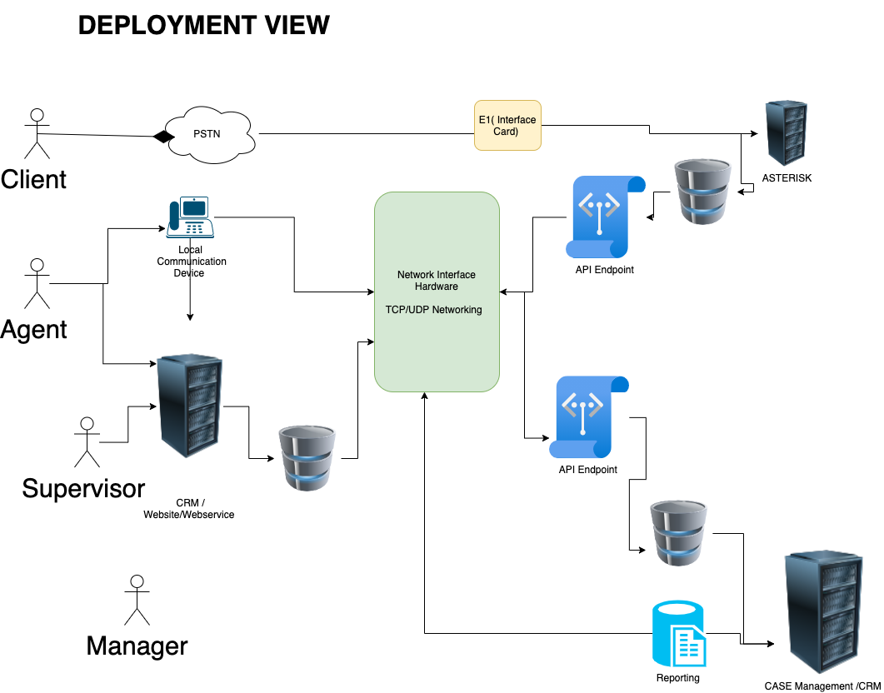
Here is a diagram of our proposed infrastructure

Operations and Roles
The system shall have the following user levels: administrator, counselor/agent, supervisor, case manager, and caseworker.
Every user level shall dashboard representative of their account roles and activity including statistics of calls and cases based on parameters such as categories, status, gender, districts, priority, and any other applicable field. The dashboards will also have graphical displays line & pie charts, bar graphs, etc.

Partners UNFPA and UNICEF
They will be assigned View roles so that they can log in to the system at any time and view the activities and statistics at the Helpline as may be required. Mostly they will be given access to view reports from the system.

Administrator
The system administrator is responsible for configurations, they can view cases, they have minimal or no action. The following are some of the roles by administrators:
- Create and update configurable parameters such as case categories and services offered.
- Manage system users.
- View reports.

Counselor
Counselors handle calls and are mainly based at the call center. They are trained to offer first-line support for both VAC. Additionally, they:
- create cases from calls
- escalate cases to supervisors
- view their own cases.
- Can search cases from all cases

Supervisor
A supervisor is the call center manager who is in charge of counselor/agent work affairs and ensures they are within the set policies of the helpline. They:
- Can create cases.
- View all cases with an option to update.
- Perform QA on calls.
- Propose system settings and updates to the administrator.

Case Manager
The case manager is mainly related to the tasks of a caseworker. They:
- Can create a case.
- View all cases escalated to them, the cases they create, and those created by caseworkers.
- Assign cases to caseworkers.

Case Worker
They are majorly concerned with non-call cases and cases assigned to them by Case Managers. They view only their cases and those assigned by case managers but can search all cases in case of follow-up.

Case Escalation Process
This is the process in which a case goes through before it’s closed. A case may be closed at the time of creation by the counselor but sometimes it requires attention from a higher level of the user hierarchy.
A counselor can escalate a case to a supervisor who in turn can escalate the case to a case manager, the case manager assigns cases to caseworkers who in most of the time are in the field.
The following information needs to be captured during the case capture flow.
A. Case Reporter Details
B. Case Category
C. Other Client Details
D. Perpetrator Details
E. Case Narrative
F. Services Offered
G. Case Action
Depending on the case status if the client is a first-time Reporter the counselor would click on Create New case otherwise if the client is a repeat Reporter/ Client the form should populate their details accordingly.

Case Categories
We have shared the list of generic categories with the client. The initial categories will be uploaded into the system at inception, However, the system allows for additional categories

Reporting Module
All activities done on the case management system will result in reports which are used by the supervisors, managers, and others to analyze the trends and be proactive and take corrective measures to mitigate situations. Both call and case reports shall have a list and statistical (pivoted) reports.
There shall be 2 main lines of reports.
- Case Management Report – reports regarding case management.
- Call Management Reports – reports pertaining to calls.

Pivot Reports
Pivot report refers to the statistical description of the data captured generated by a system user based on select report fields. It presents fields on an X and Y axes form and is filtered by date and/or date range.
This gives a permeation & combination of the type of reports required and the different data required. Additional fields can be provided for filtering the reports. This applies to both call and case reports.
The report should be printable or exportable to acceptable formats such as PDF or spreadsheet.

Comprehensive Reports
These are the main types of reports with listings of records are collected by the system. The module should provide filters for all of these kinds of reports to allow users to get what is needed for a particular purpose. The filter may include date created, location, categories, gender, status among others.
These reports include:
· Call Reports
· Case Reports
· Counsellor Reports
· Performance Reports

The comprehensive reports shall have the export options to formats such as XLSX, CSV, XLS, and PDF either for further analysis or presentation.

Proposed Process Flows

Call process flow

Call 116
Welcome IVR
Welcome IVR
Call Answered?
Exit IVR
Voicemail?
End
Voicemail message IVR
Case Capture/Follow Up

Case Capture process Flow.
GBV Related
VAC
GBV
Reporter details
VAC Client Details
GBV Client Details
Additional VAC Fields
Additional GBV Details
Perpetrator Details
Case Details
Services Offered
Case Action/Closure
Follow Up
Search Historical Cases

Conclusion
The existing infrastructure and the current system require a complete overhaul the CHL systems provide a perfect opportunity to improve the process at the CHL center. Eventually, we expect that the volume of calls and cases at the helpline will increase exponentially.
With all the stakeholders working together we believe that the consultant will successfully deploy the envisaged system in the timeframe provided of 35 days.

Appendix 1: Proposed Data Fields
Reporter Details
What is your name? (Text Field)
Enter your contact phone number (Text Field)
What is our preferred Language? (Drop down of all languages)
Reporter Sex (Radio button for Male, Female, Hermaphrodite, Unknown)
Reporter Age Group (Drop Down for 0-4, 5-9, 10-13, 14-17,18 and Above)
Select District (Dropdown of All Districts)
Alternative Contact (Text Field)
Email Address (Text Field)
Are you directly affected? (Radio Button for Yes or No)

Client Details
What is your name? (Text Field)
Client Sex (Radio button for Male, Female, Hermaphrodite, Unknown)
Client Age (Text Field)
Select Client District (Dropdown of All Districts)
Nearest Landmark
Guardian Name (Text Field)
Is the person attending school? (Radio Button for Yes or No)

Perpetrator Details
What is the name of the perpetrator? (Text Field)
Select perpetrator sex Client Sex (Radio button for Male, Female, Hermaphrodite, and Unknown)
What is the relationship with the client? (Drop down with Father, Mother, Brother, Sister, Uncle, Aunt, Nephew, Niece, Teacher, Neighbor, Other related, other not related, unknown)
Does the perpetrator share household with the affected person? (Radio Button for Yes or No)
Select Perpetrator District (Dropdown of All Districts)

Case Narrative
Fill in the case narrative (Text Field with “Tell us a short story of what happened”)
Has the case been reported to any other organization? Drop down with At Police, In court, Convicted, Released, Unknown)
SUBMIT

Appendix 2: Proposed Case Categories
# | Category | Subcategory
 | Abuse
 | Murder | - Child Death due to Abuse  - Attempted Murder  - Child Sacrifice  - Abortion  - Mysterious Death  - Poisoning  - General
 | Physical Abuse | - Corporal Punishment  - Electric-shocking  - Beating  - Burning  - General
 | Emotional Abuse | - Labelling  - Witness to Violence/Abuse  - Bullying  - Verbal Attack  - General
 | Child Trafficking | - Internal Trafficking  - Cross Border Trafficking  - Abduction/Kidnapping  - General
 | Child Exploitation | - Child Labour - Commercial  - Children used for Criminal Activity  - Children used for Begging  - Child Labour - Domestic  - Child Labour - Bonded  - Child Labour  - Commercial Sex Exploitation  - General
 | Child Neglect | - Denial of Education  - Child Malnutrition  - Child Abandonment  - Child Maintenance  - General
 | Sexual Abuse | - Defilement  - Exposure to Pornographic Materials  - Sodomy  - FGM (Female Genital Mutilation)  - Teenage Pregnancy  - Early/Forced Marriage  - General
 | Online Child Sexual Abuse And Exploitation | - Online Extortion and Blackmail  - Victim of Online Sexual Exploitation  - Exposure to Online Child Pornography  - Victim of Online Child Pornography  - Attempted Defilement  - Victim of Online Child Sexual Exploitation  - Online Grooming for Sexual Purposes  - Unwanted Sexting  - Revenge Pornography  - General
 | Counselling
 | Boy/Girl Relationship
 | Student or Teacher Relationship | - Teacher Problems  - Student in Problems with School Authority  - Abortion
 | Stress/Depression
 | Self Esteem
 | Reproductive Health Issues
 | Loss and Grief
 | Career Guidance
 | Juvenile Delinquency
 | Family Issues | - Divorce/Separated Parents in Conflict  - Sibling Relationship  - Family Member in Conflict
10. | Parent or Child Relationship | - Unmanageable Children
11. | Parental Guidance | - Positive Parenting  - Coping with Single Parenthood
12. | Peer Influence
13. | HIV Counselling
14. | Child Custody | - Institutionalization  - Adoption  - Paternity/Maternity Rights
15. | Child In Conflict with the Law | - Child Imprisonment  - Juvenile Delinquency  - Child to Child Sex
16. | Marital Issues
17. | Addiction | - Drugs  - Smoking  - Alcohol  - Gambling  - Gaming  - Pornography  - Social Media/Internet  - Food  - Masturbation
18. | Mental Issues
19. | Legal_Issues | - Child in need of representation  - Child Witness  - Law in Conflict with Children's Rights  - Child in Conflict with the Law  - Child Imprisonment  - Child Imprisoned with adult Person  - Pre-Trial Briefing
20. | Child to Child Sex
21. | Lost Child | - Seeking shelter  - Missing Child  - Homeless Child  - Lost Child
22. | Life Skills
23. | Property_Rights | - Inheritance issues  - Property grabbing
24. | Differently_Abled_Persons | - Deaf  - Visually Impaired  - Mental Disability  - Physical Disability
25. | Orphans | - Child headed families  - Orphan in need of care and support  - Orphan in need of school fees  - Orphan living with elderly person  - Orphan living with HIV-Infected person
26. | Street Child
27. | Discrimination | - Age  - Ethnicity  - HIV/AIDS  - Marginal/Vulnerable Groups  - Criminal Record/Ex-Prisoner  - Access to Education
28. | Run Away Child
 | Medical Aid | - In need of medical assistance  - Access to health care  - Concerns about illnesses
 | Information Inquiry
 | Pre-trial Briefing
 | Inquiry on Other Services
 | Information on Helpline Services
 | Financial Aid
 | Employment/Job
 | Topical Issues (Child rights, Biology etc)
 | Case Update
10. | Birth Registration
11. | Appreciation
12. | In Need of School Fees

